Julio Payao

06/28/2019

HomeWork Module 1

Assignment01

Title

Introduction : Create a project using HTML,Javascript and ASP,NET

Topic 1: Start creating an Empty Project see Figure 1

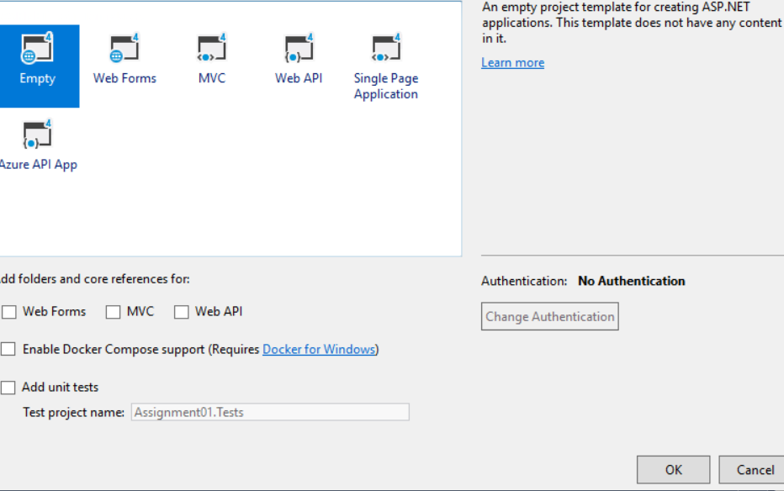

Topic 2: Create a Html pages and name Demo01JP using Html and input and summit keyword.

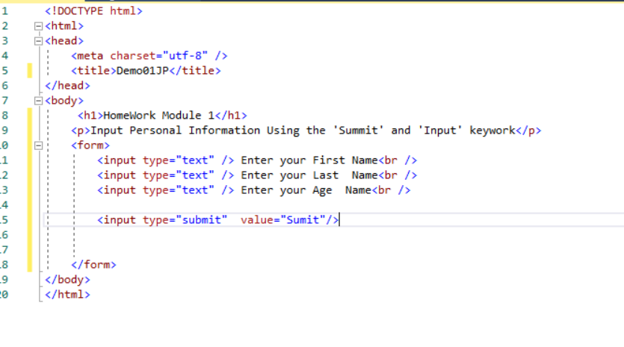Figure2 example of Code

Figure 3 Web pages using Html

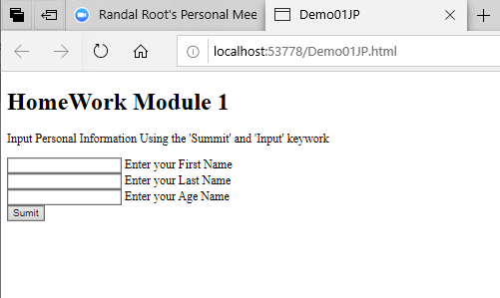

Figure 4 : Add Javascript code to the Html pages.

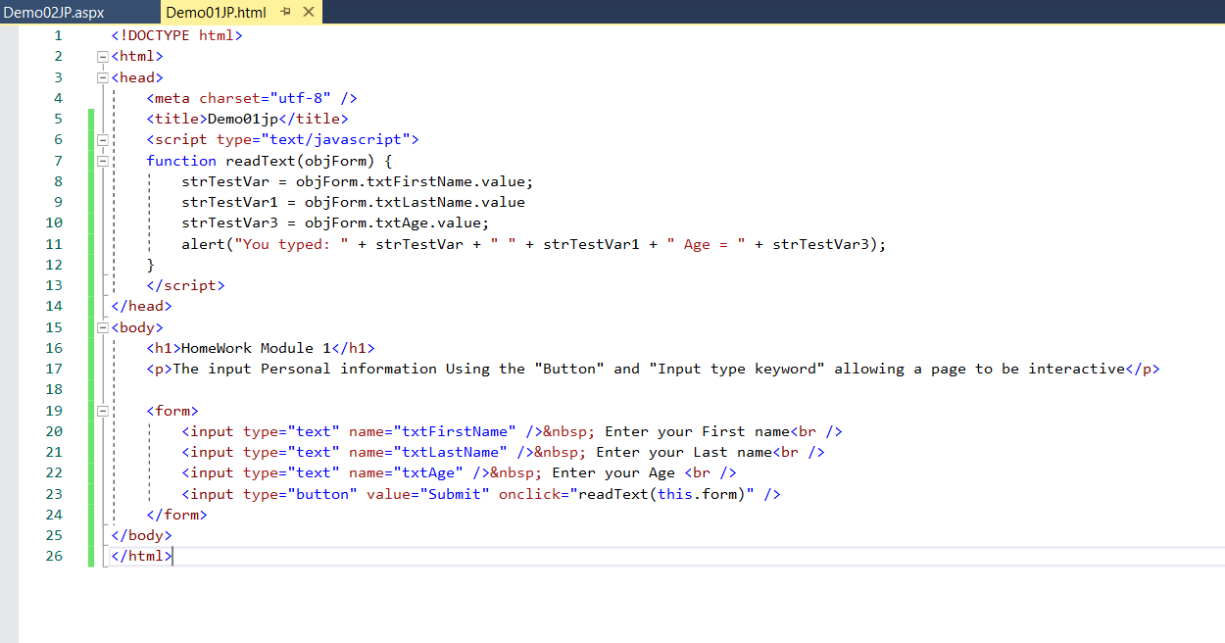

Figure 5 Web page Display using Html and Javascript

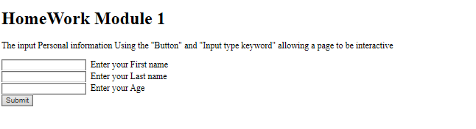

Figure 6 Web page Display Information

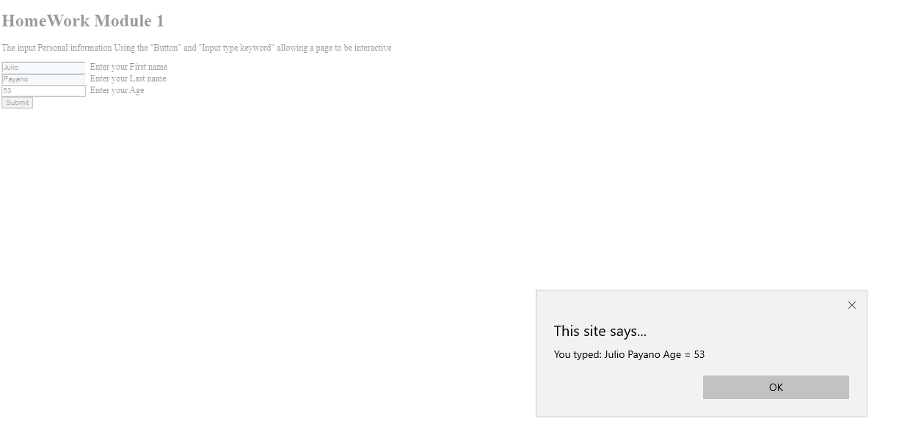

Topic 3 Include ASP.net to the pages. From Book Beginning ASP 4.5

In this code the execution es on the server

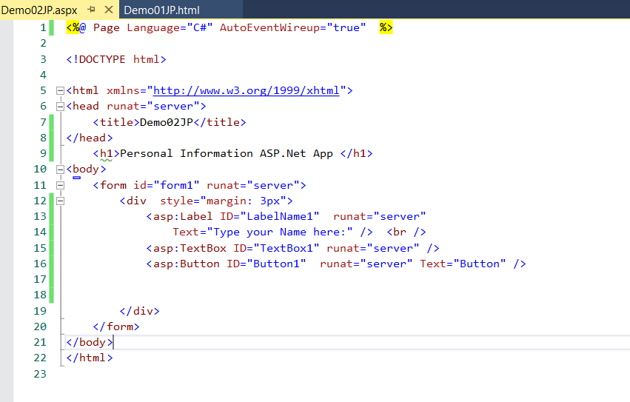

Summary In this Module I learn how to create a pages using Html javascript and ASP.net . Display data from the Browser and from the server.